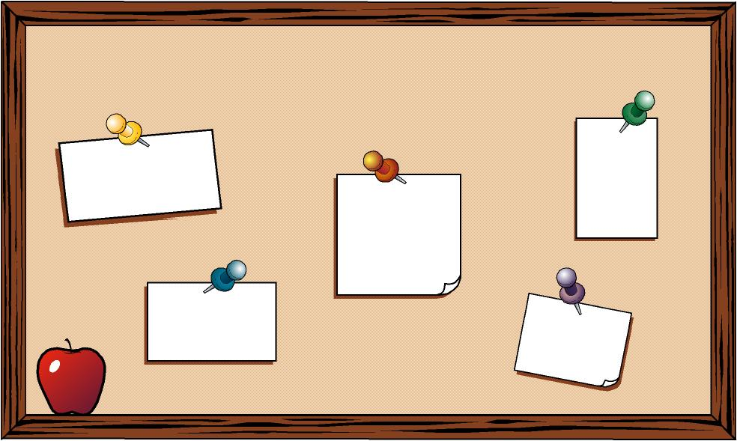
Grade 8 English Language Arts students will be taking part in an independent novel study and will be taking part in the Bulletin Board Project.

Grade 8 students will be selecting a novel from the library to read for their Bulletin Board Project. Students will be creating a bulletin board display that will be showcased in the library during a select time throughout the school year.

The bulletin board will serve as an introduction to the particular novel that the student has studied. Each student will be responsible for creating a bulletin board with the necessary requirements.

Step 1: Pick a novel / read the novel
- Each student must pick a novel found in the library to read.

- The novel must be age/skill appropriate (Ask Miss. Fingas or Mrs. Kentner if you are unsure of your novel).

- Each student must pick a different novel. Once you have chosen your novel you must write it down on the classroom chart to “save” your novel. If a novel is already taken you must select a different novel.

- READ YOUR NOVEL! Students will be given 1 library period a cycle (day 4) and select class time to work on the assignment.

Step 2: Create the Bulletin Board Project
- You will begin creating the necessary Bulletin Board Project requirements once you have completed the novel:

Bulletin Board Project
- Novel Title / Author
Somewhere on the bulletin board must display the name of your novel and the author of the novel. It should be in an easy to read font that catches the eye of others. The title of your novel and the author’s name should be the LARGEST item on the bulletin board.

- Copy of the Book Cover
Print off an image that shows viewers what the front of the book cover looks like. Sometimes books have more than one cover; use the same cover as the book from the library. This should be approximately a page in size and should be printed in color.

- Novel Summary
You will be required to write and type up a one- page (250 words / double spaced) summary of your novel explaining what happened in the beginning, middle, and end. Do not give too much information away. Use the graphic organizer provided to help you.

- Character Image
You will be creating a visual representation (picture) of your main character. It could be a black and white sketch, colored with pencil crayons, or painted. Sketch the character the way you see him/her in your head. Your picture should be approximately one page in size. Don’t forget to label the picture with the name of the character.

- Book Review
You will be required to type up a one-page (250 words / double spaced) book review of the novel you read. You will inform viewers what you liked/disliked about the novel, the best part, and why someone should read/not read this novel. In addition, you need to give

your book a star rating (out of 5) and show the stars visually. The stars should be large in scale and eye catching.

- Shoebox Diorama
You will be creating a shoebox diorama. The idea is to capture a scene in the novel and display it within a shoebox. You will be required to type up a one-page (250 words / double spaced) summary stating what is going on in the scene and why you chose it as the most important part of the novel. Your shoebox diorama will require you to be creative!

- Your Name
You must display your name (first and last) somewhere on the bulletin board so that viewers know who created the display. This should not be the entire focus of your bulletin board but should be large enough that people can easily see this information.

When Will I Have Time to Complete This?
- Library periods
- Select class periods
- Homework

Hints / Tips / Suggestions
- Everything needs to be neat and organized. This bulletin board is on display to the entire school!

- Everything should be typed or neatly printed (if it cannot be typed).

- Remember grammar / punctuation and use your best writing.

- Use the entire bulletin board to showcase your work. Think about the size of your typing / images. Everything needs to be LARGE.

Further information on the Bulletin Board Project will be provided (aka handouts to explain how to write a summary, book review, and how to do a shoebox diorama). We will spend time talking about each component during class.

Bulletin Board Projects are all due on the same day but will be displayed at different times during the school year in the library. A schedule will be created so all student’s projects will be on display.

Due Date: Monday November 10th 2014

